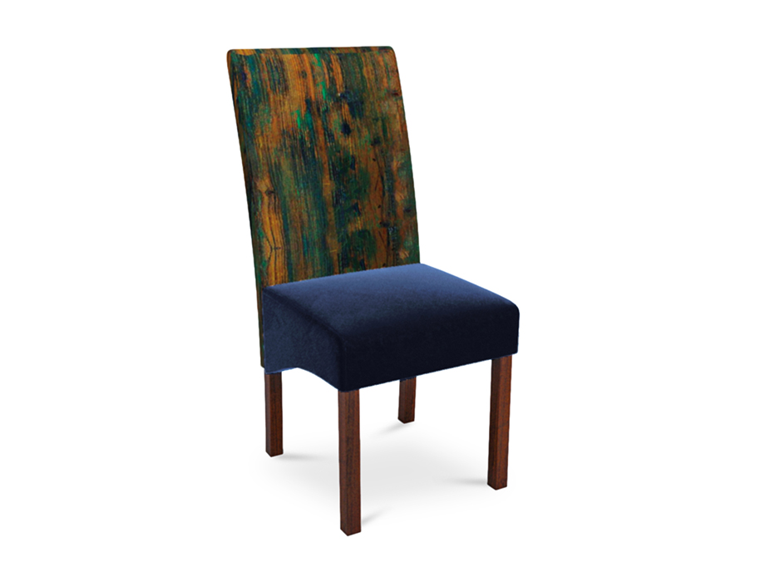

# Dining Chair Java

PKR 18,011PKR 21,700

Design:

Java

Delivered in :04 - 06 Working Days

Material:Wood/Fabric

Size:

* + 590 W x 460 D x 1040 H (mm)
  + 23 W x 18 D x 40 H (Inches)

Note: The actual colours may vary from those shown depending on the device you are using to view the product or the angle of the item is photographed.